AdwPortal Summary Flowcharts Process
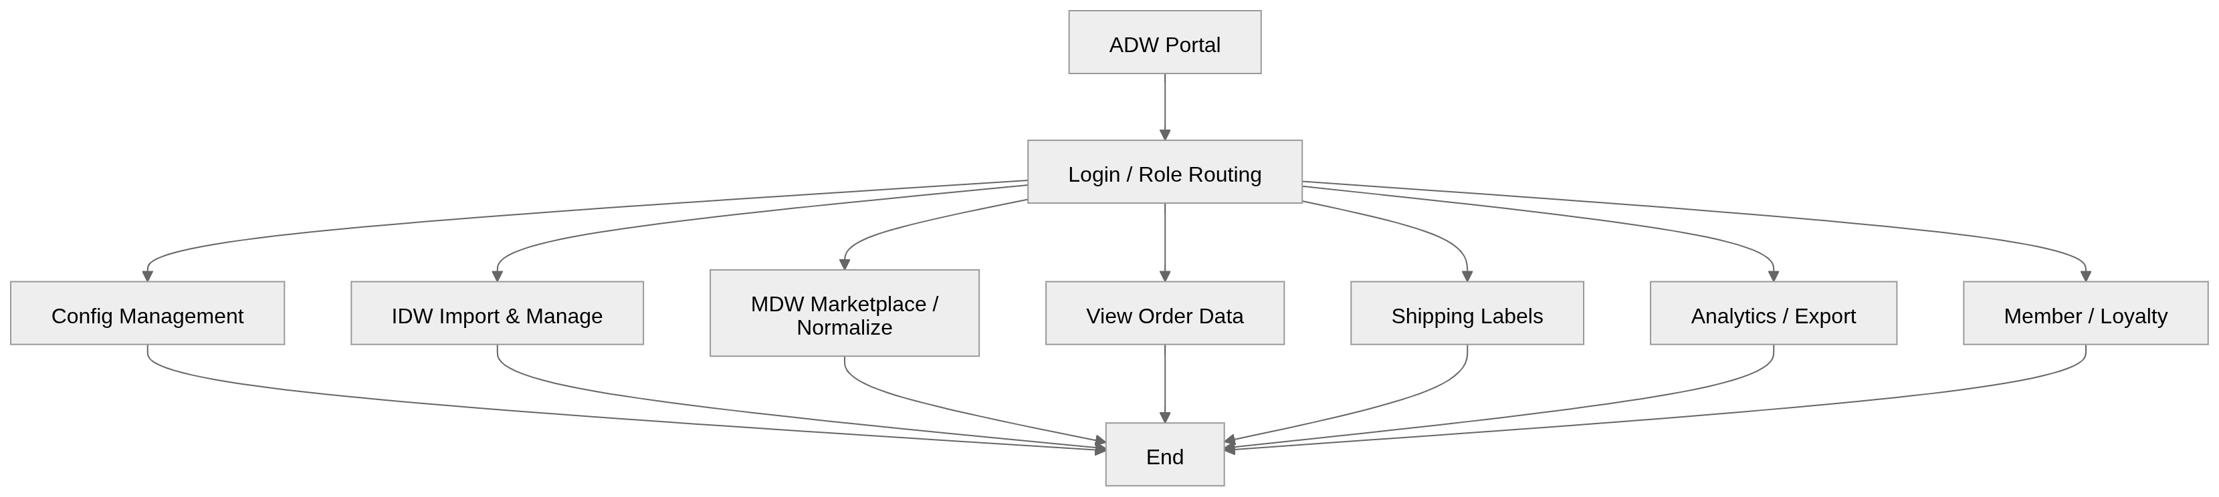

1) Login / Role Routing Process
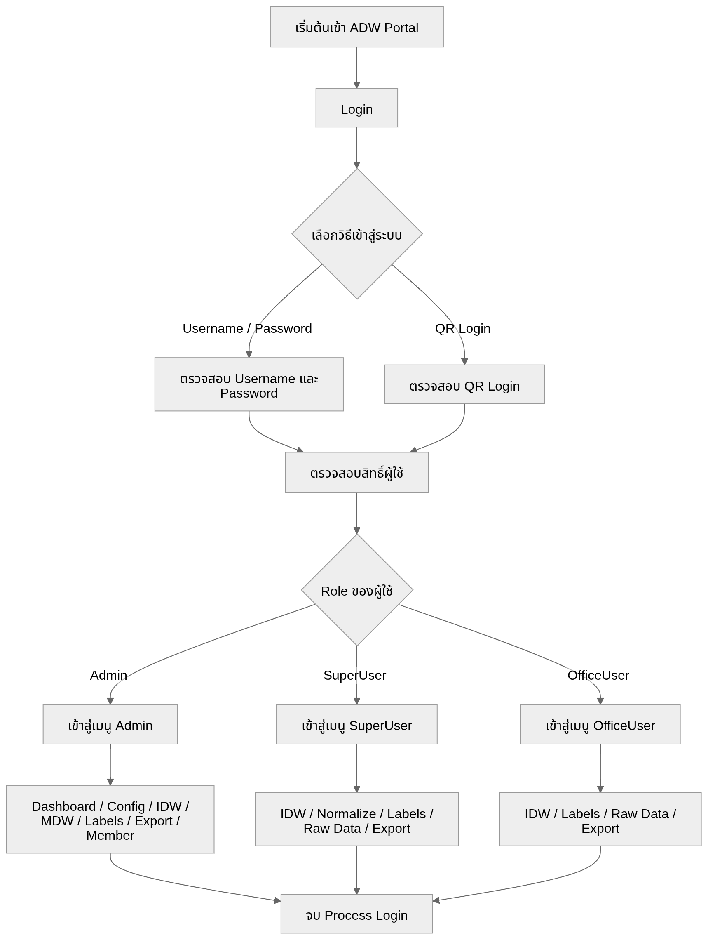

2) Config Management Process
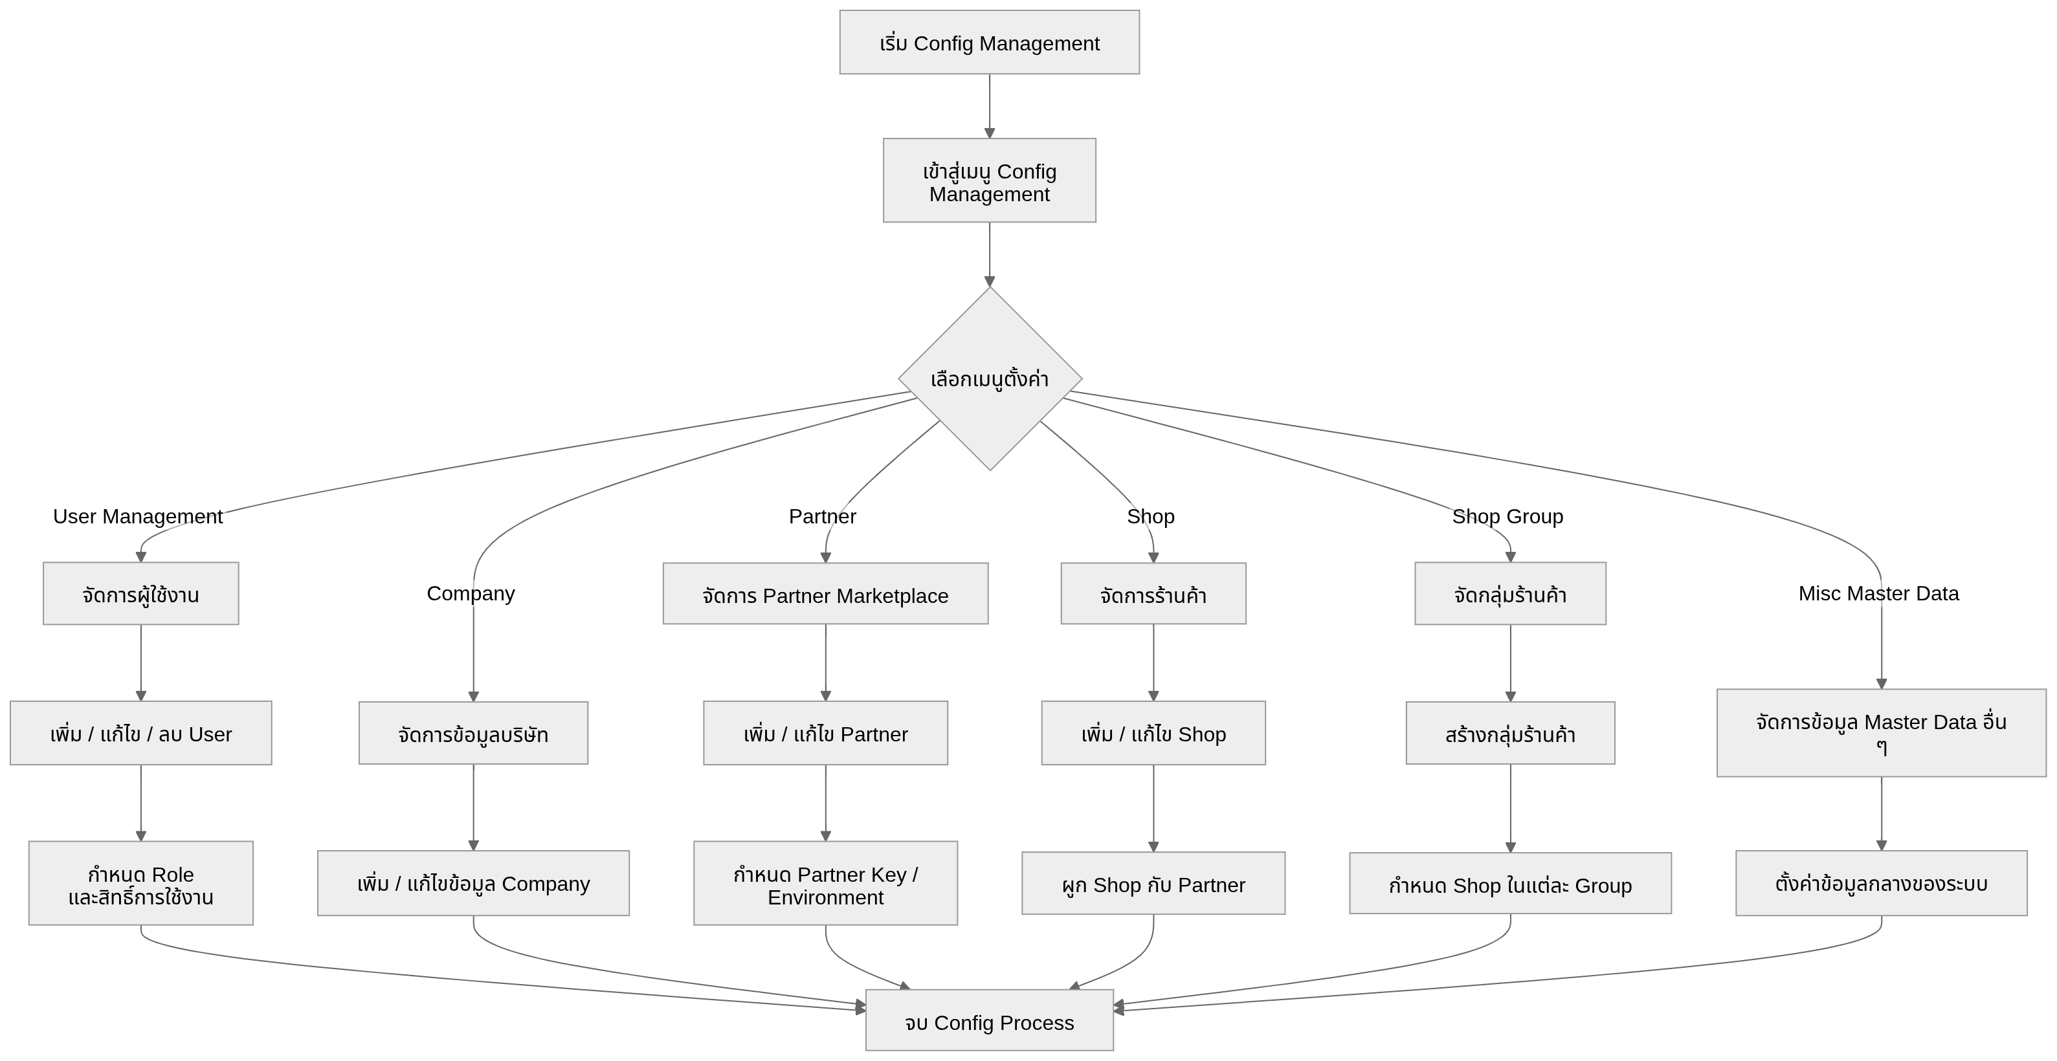

3) IDW Import & Manage Process
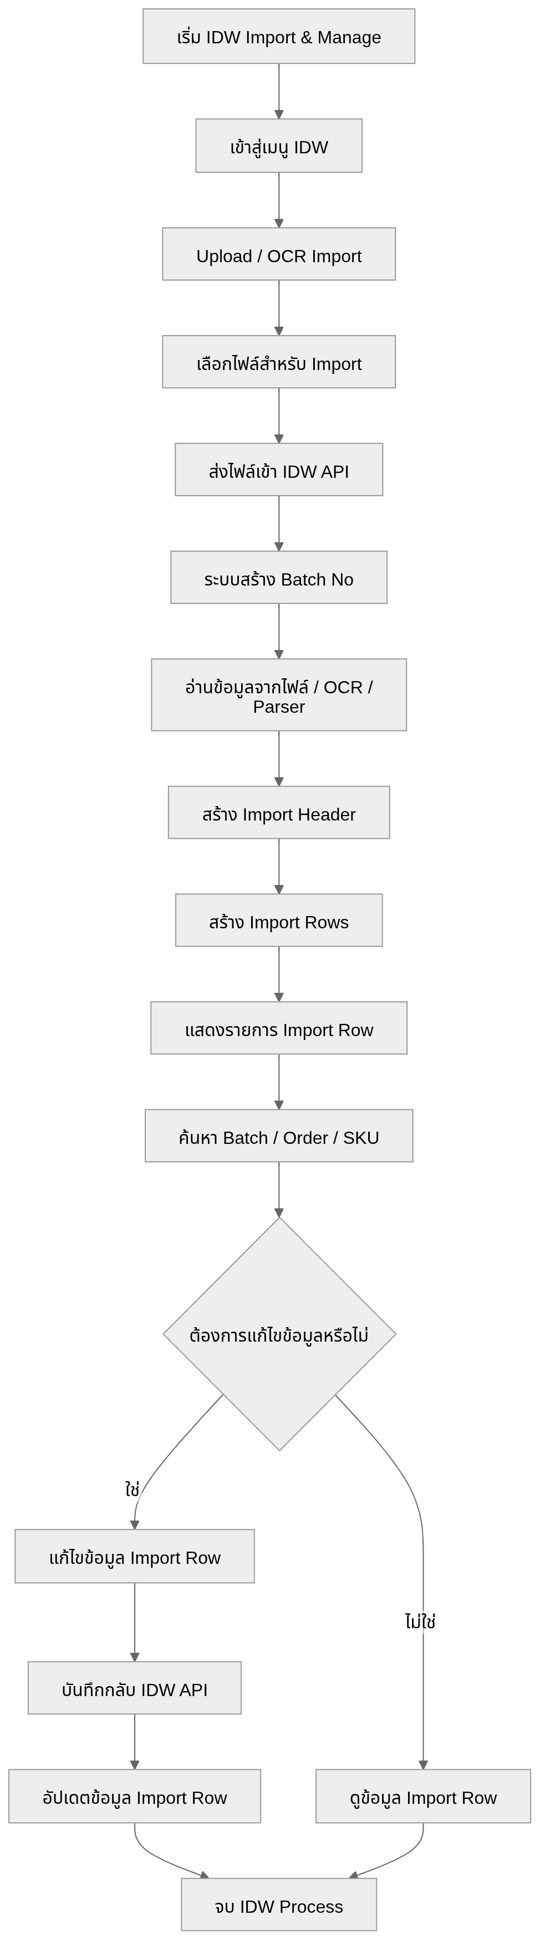

4) MDW Marketplace / Normalize Process
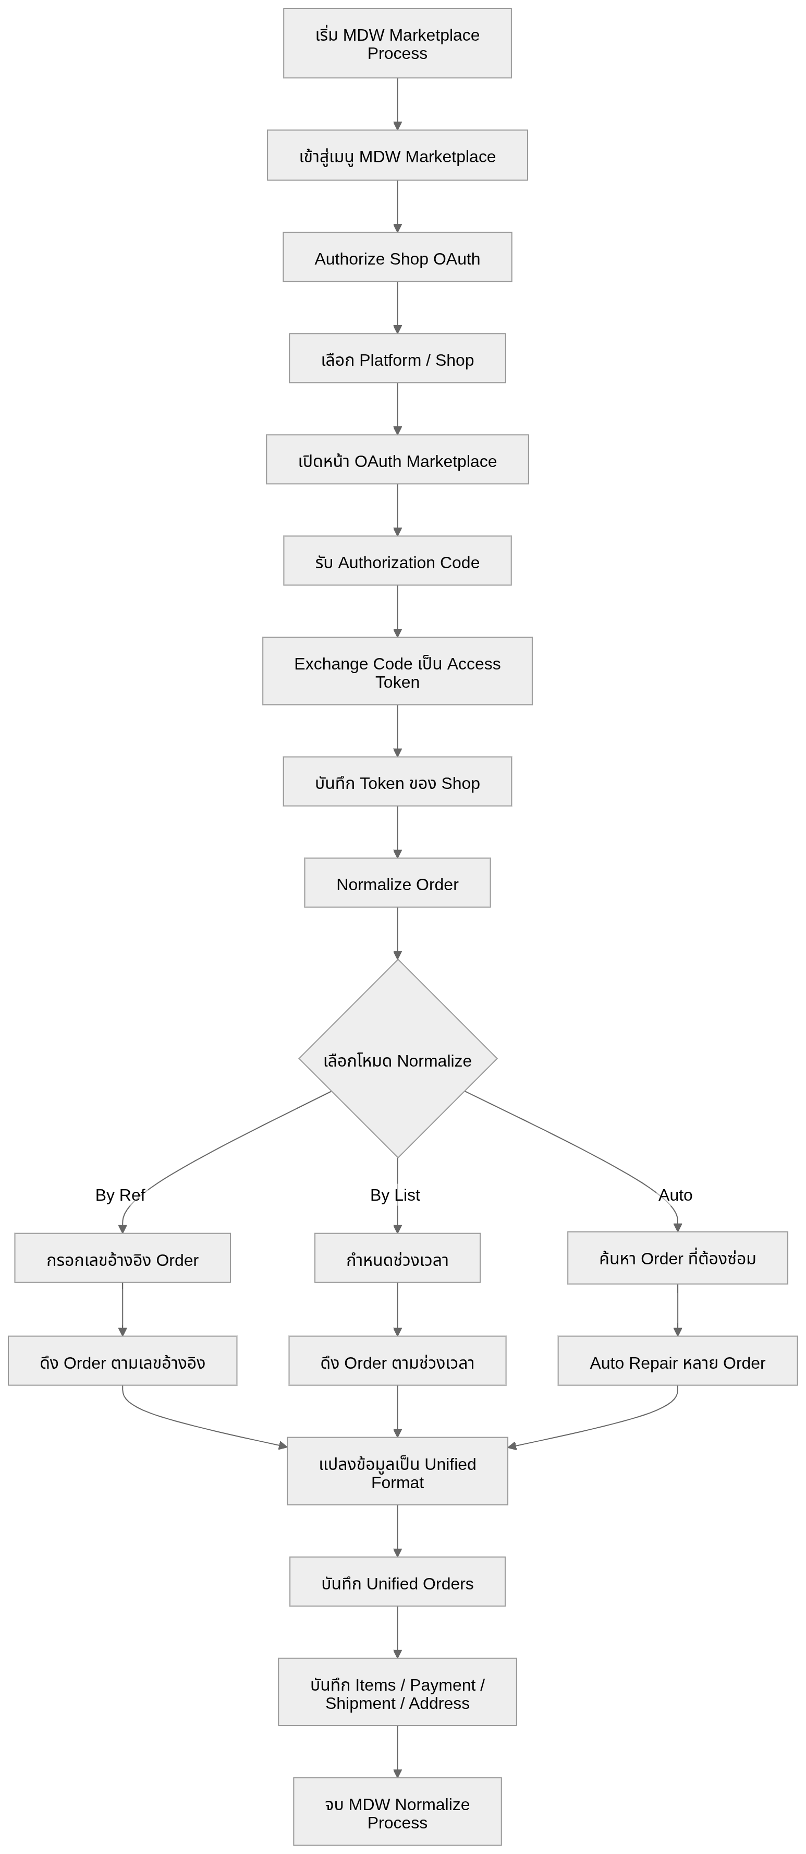
5) View Order Data Process
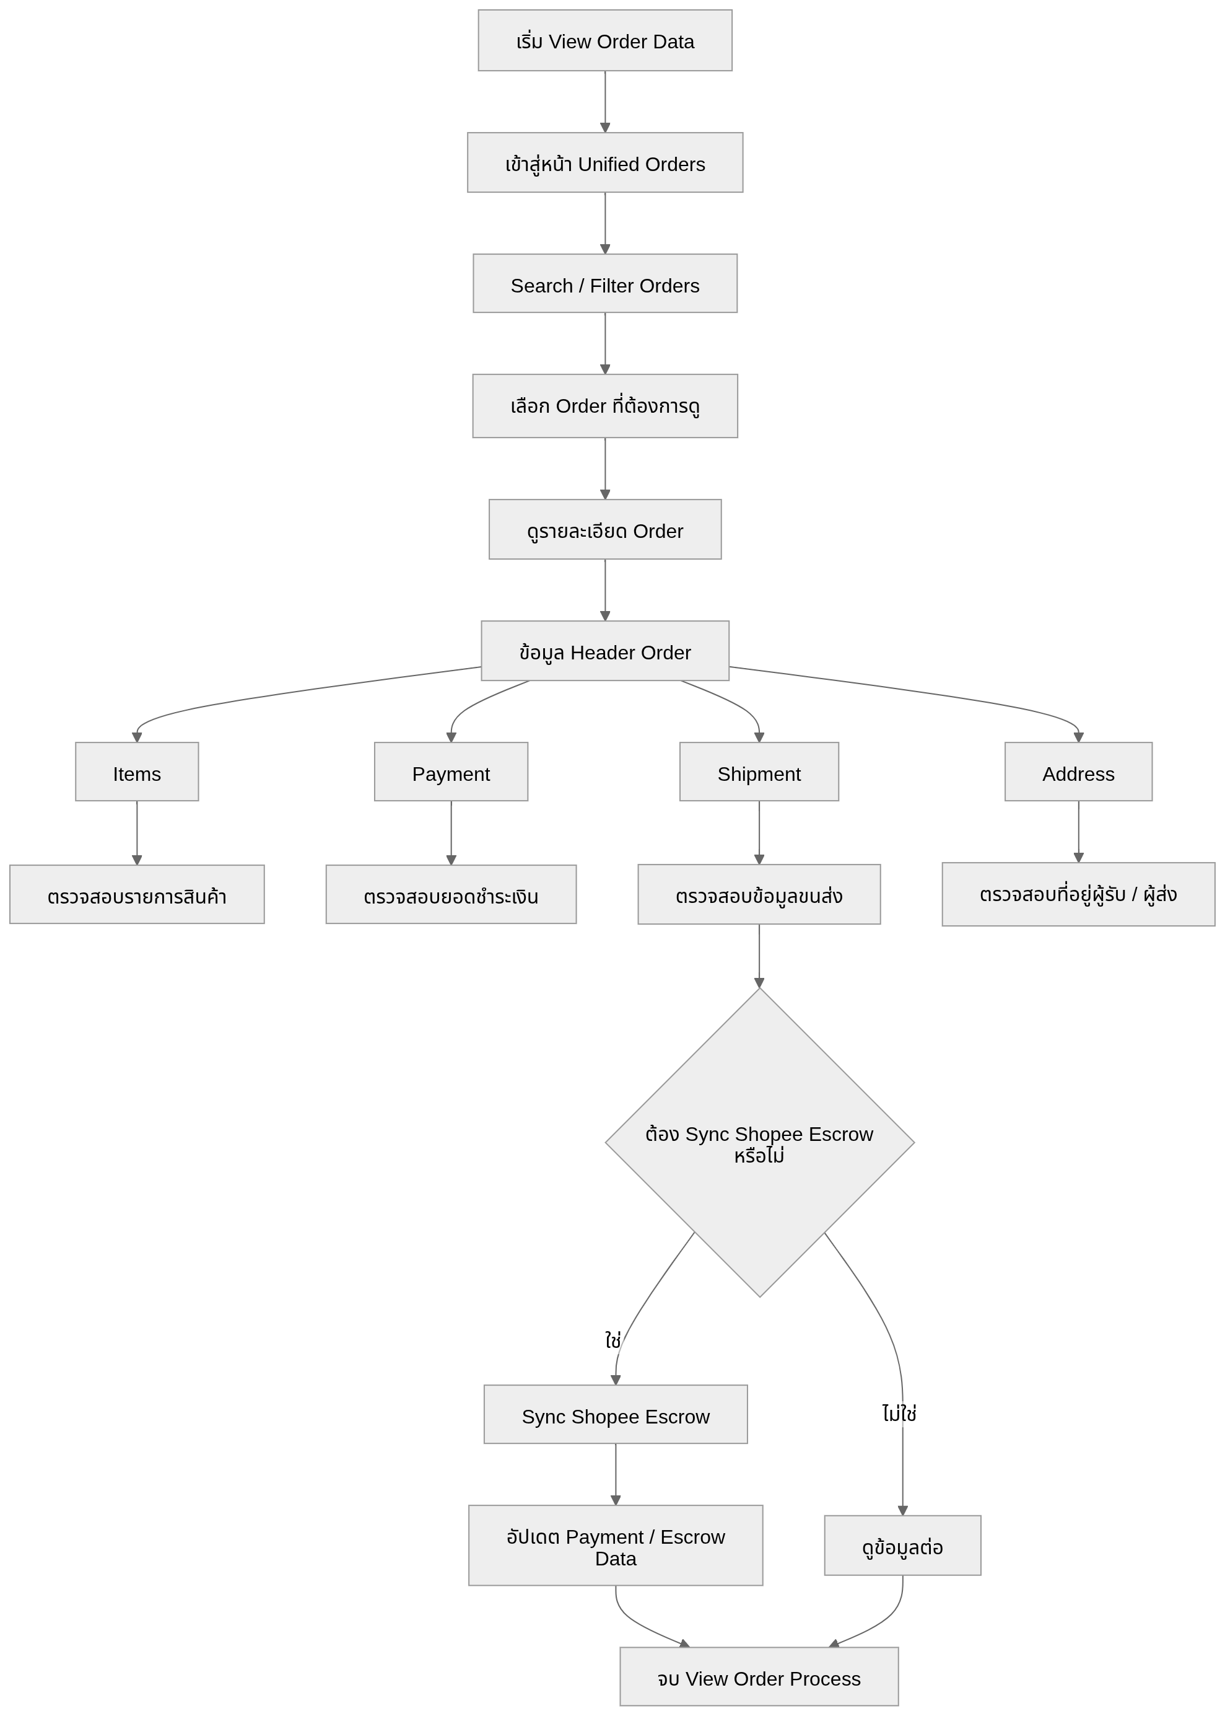
6) Shipping Labels and OCR Process
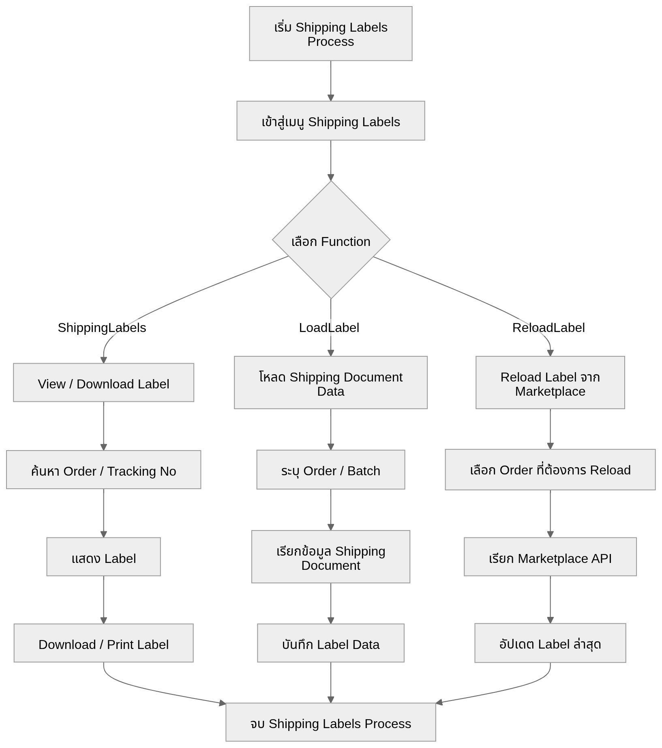

7) Analytics / Export Process
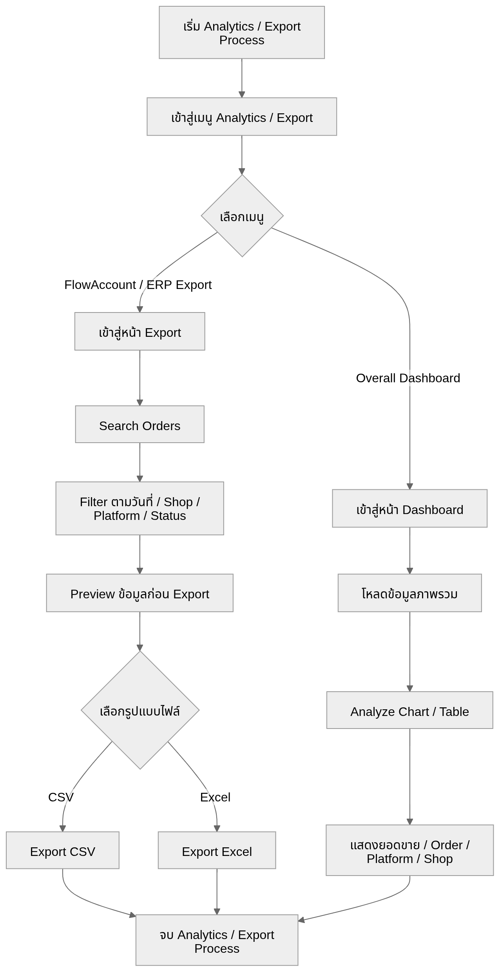
8) Member / Loyalty Process
